**PROJECT TITLE: SMART WATER FOUNTAINS**

NAME: Gesindha.k

COLLEGE CODE: 9530

PROBLEM SOLUTION:

Our goal is to design a smart water fountain that can monitor the water quality and automatically replace water when polluted(not healthy) or running out. We will use sensors to measure the water quality. Common water quality measurement factors include temperature, Ph-value, conductance, turbidity and hardness. Considering the pollution at home can only affect limited factors, we choose temperature, Ph-value and conductance to be the three properties used for calculating water quality in our water fountain. These data will be collected, calculated, and reflected to the user in terms of “Good”, “Average” and “Bad”. The water fountain is also designed to self-filter the water every time when water is pumped through the submersible water pump.

FLOW CHART:

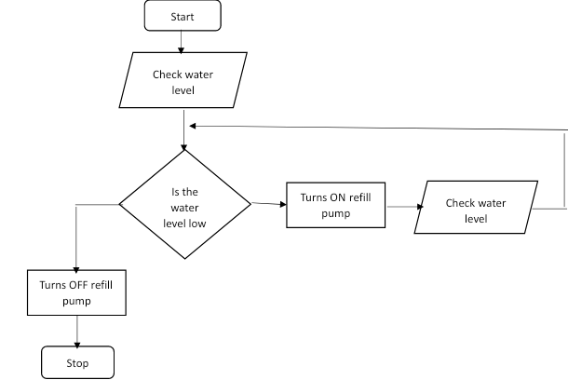

Creating a smart water fountain IoT project using a Raspberry Pi 3 requires a combination of hardware and software components. Here are the steps to create such a project:

Hardware Components:

1. Raspberry Pi 3 Model B or later

2. Water pump

3. Relay module

4. Water level sensor (optional)

5. Power supply for the pump

6. Tubing and fountain nozzle

7. Waterproof container for the water reservoir

8. Various cables, connectors, and a breadboard

Software Components:

1. Raspbian OS (or a suitable Raspberry Pi OS)

2. Python for programming

3. IoT platform (e.g., MQTT, AWS IoT, or Google Cloud IoT Core)

4. Libraries for GPIO control (e.g., RPi.GPIO)

5. Optional: Web server and HTML/CSS/JavaScript for a web-based user interface

Steps to Create the Smart Water Fountain:

1. Set Up Raspberry Pi:

- Install Raspbian OS on your Raspberry Pi.

- Update the system packages using `sudo apt-get update` and `sudo apt-get upgrade`.

2. Hardware Setup:

- Connect the water pump to a relay module. The relay will allow the Raspberry Pi to control the pump's power.

- Connect the relay module to the GPIO pins on the Raspberry Pi. Make sure to connect it properly, following the GPIO pinout for your model.

- Optionally, you can connect a water level sensor to the Raspberry Pi to monitor the water level in the reservoir.

3. Install Required Libraries:

- Install the necessary Python libraries for GPIO control, such as RPi.GPIO.

- You may also need additional libraries for sensor data (if using a water level sensor) and for connecting to your chosen IoT platform.

4. Code the Fountain Control:

- Write a Python script that reads sensor data (if used), controls the water pump through the relay, and sends status updates to your chosen IoT platform.

- You'll need to program the logic for when to turn the pump on and off based on sensor data or a predefined schedule.

- Make sure to handle exceptions and errors in your code.

5. IoT Integration:

- Set up your chosen IoT platform (e.g., AWS IoT, MQTT broker, Google Cloud IoT Core) and create a device or topic to which your Raspberry Pi can publish data.

- Modify your Python script to connect to the IoT platform and publish status updates.

6. Optional: Web Interface

- Create a web-based user interface for controlling the water fountain remotely using HTML, CSS, and JavaScript.

- You can use libraries like Flask to create a web server on your Raspberry Pi.

7. Assemble and Test:

- Assemble all the components in a waterproof container with the water reservoir, pump, and tubing.

- Test the system to ensure that it turns the pump on and off correctly based on your code and sensor inputs.

- Test remote control and monitoring via your IoT platform.

8. Finalize and Deploy:

- Once everything is working as expected, secure the components and deploy your smart water fountain in the desired location.

Remember to follow safety precautions when working with water and electrical components, and consult relevant datasheets and documentation for your specific hardware components.